Sutton Municipal Center
4 Uxbridge Road
Sutton, MA. 01590
Telephone (508) 865-8724
Fax (508) 865-8721

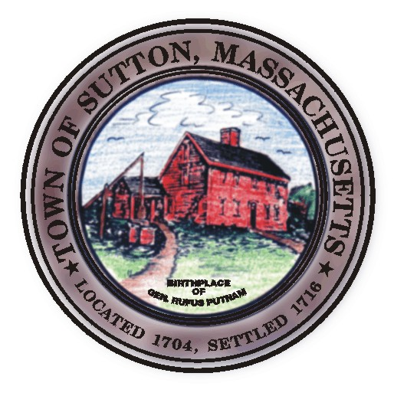
Dr. Steven Rice, Chairman
John Silverberg, Vice Chairman
Diane Miller, Member
William Fredericks, Member
Kenneth Malo Jr., Member
James Malley, PE
Cheryl Rawinski, Public Health Nurse
Christine Fant, Administrative Assistant

TOWN OF SUTTON

Board of Health Meeting

April 13, 2009

- 8 West Sutton Road , local upgrade, DEP upgrade

- Kings Campground

- Departmental Update

- Minutes

- New/ Old Business

Posted in the Town Clerks Office

April 9, 2009

